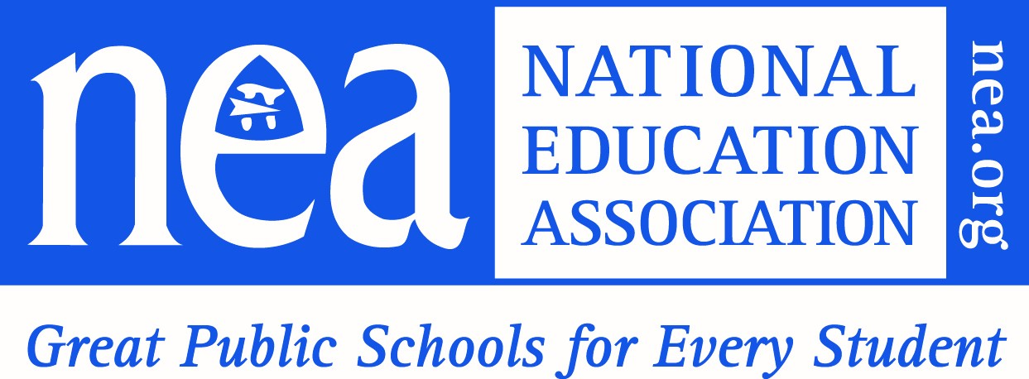

THE APPLICATION ​
Grants for K-12 Affiliates
www.takealookatteaching/k12grants
Local Name:
Local President Name:
Member ID#:
Contact Person (if different than the Local President):
Member ID #_____________
Email Address:
Work Email:(Optional)
Cell Number (Optional)

Proposed Project Narrative

- Provide a statement of need for your project.

- List the three goals you will focus on during the grant period.
Goal One:

Goal Two:

Goal Three:

- Describe the key activities and structures you will implement to grow your own teacher pipeline of future educators? For example, create a club, offer an introduction to education course, provide mentoring and tutoring experiences for students, and or partner with a higher education institution to offer college and career activities.

- Will your activities be implemented over the three-year grant period?
- Yes
- No

- Which student population(s) will be served?
- Middle
- High School
- College Students

- Estimate the number of students you will serve in Year One:

- How do you plan to increase the diversity of the teacher pipeline?

- What diversity characteristics will your efforts address? (Select all that apply) The priority focus of the grant is to diversify the talent pool of the teacher pipeline.

- Race______
- Ethnicity_____
- Gender______

Geographic
- Rural_____
- Urban_____
- Suburban_____
- Other (please specify)

- What other student populations will your pipeline efforts address?
- First-Generation College Students_____
- Low-Income Students______
- Cultural Diversity______
- My Brother’s Keeper/Males of Color______
- Other (please specify): __________________

Member Engagement

10. Describe how you will engage union members and or non-members in this project? Which populations will you include in this project?
- Educators of Color ___
- Early Career Educators ___
- Retirees ___
- School Related Professionals ___

Community Partnerships

11. List the names of the community partners you will join forces with to support the teacher pipeline effort. What role will not-for-profits, community groups and leaders that make up the local community play in engaging with students and families and supporting their entry into teaching? Are these new partners or have you worked with these partners in the past? How will these partners enhance program success?

Higher Education Partnerships

12. Which four-year institutions and/or community colleges will you partner with during the grant period? Your higher education partners can include SUNY/CUNY and private institutions. Please describe your proposed collaborative work.

Labor-Management Collaboration

13. Identify school labor-management partners who will support this project, and what agreements will be in place to ensure successful implementation and sustainability (i.e. labor-management letter of agreement, data-tracking, hiring practices, professional development, use of facilities, support for afterschool club, contractual agreements).

Sustainability

14. How will the pipeline be sustained beyond the grant period? In addition to planning for financial sustainability, consider other aspects of sustainability. For example, will you seek support from the school board to continue the TALAT club and pipeline activities? Will you maintain partnerships with higher education and community partners? Will you create a collaborative with other locals in the area to continue the work?

